**Liver Patient Analysis**

**Introduction to project:**

Liver diseases averts the normal function of the liver. Mainly due to the large amount of alcohol consumption liver disease arises. Early prediction of liver disease using classification algorithms is an efficacious task that can help the doctors to diagnose the disease within a short duration of time. Discovering the existence of liver disease at an early stage is a complex task for the doctors. The main objective of this project is to analyse the parameters of various classification algorithms and compare their predictive accuracies so as to find out the best classifier for determining the liver disease. This paper focuses on the related works of various authors on liver disease such that algorithms were implemented using Weka tool that is a machine learning software written in Java. Various attributes that are essential in the prediction of liver disease were examined and the dataset of liver patients were also evaluated. This paper compares various classification algorithms such as Random Forest, Logistic Regression and Separation Algorithm with an aim to identify the best technique. Based on this study, Random Forest with the highest accuracy outperformed the other algorithms and can be further utilised in the prediction of liver diseaserecommended to the user.

**Technical Architecture:**

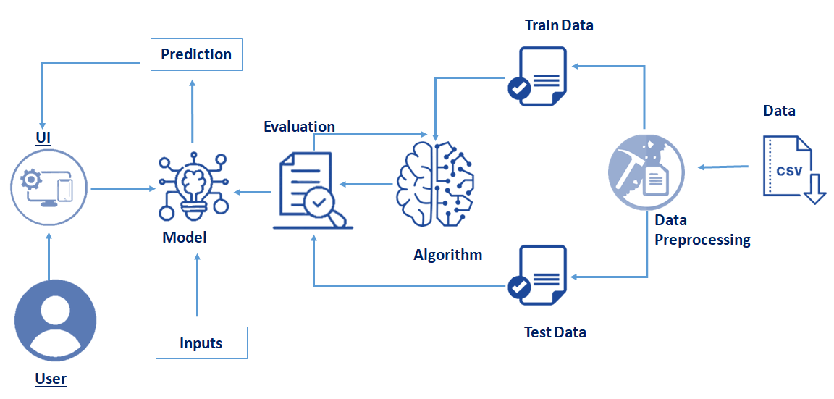

**Pre requisites:**

**To complete this project, you must require following software’s, concepts and packages**

* **Anaconda navigator:**
  + Refer to the link below to download anaconda navigator
  + **Link : https://www.youtube.com/watch?v=5mDYijMfSzs**
* **Python packages:**
  + open anaconda prompt as administrator
  + Type “pip install tensorflow” (make sure you are working on python 64 bit)
  + Type “pip install flask”.

or

* + Open anaconda prompt as administrator
  + Type “pip install -r requirements.txt” (make sure you are working on python 64 bit)

The above requirements.txt files allow you to install all the required files in the anaconda environment for your project.

the above steps allow you to install keras and tensorflow in the anaconda environment

* **Machine Learning Concepts** 
  + **SVM:** https://www.analyticsvidhya.com/blog/2017/09/understaing-support-vector-machine-example-code
  + **Random Forest:** <https://medium.com/capital-one-tech/random-forest-algorithm-for-machine-learning-c4b2c8cc9feb>
  + **KNN:** https://www.analyticsvidhya.com/blog/2018/03/introduction-k-neighbours-algorithm-clustering
  + **Flask Basics** : <https://www.youtube.com/watch?v=lj4I_CvBnt0>
* **Launch Jupyter**
  + Search for Anaconda Navigator and open Launch Jupyter notebook.

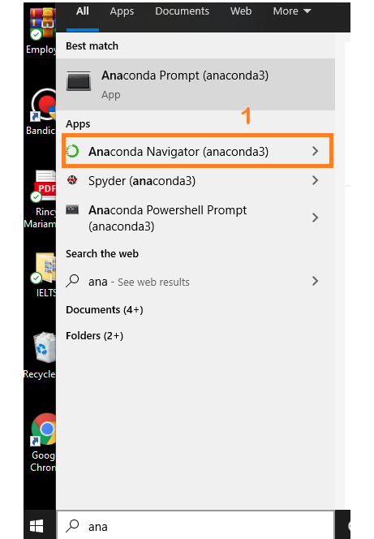

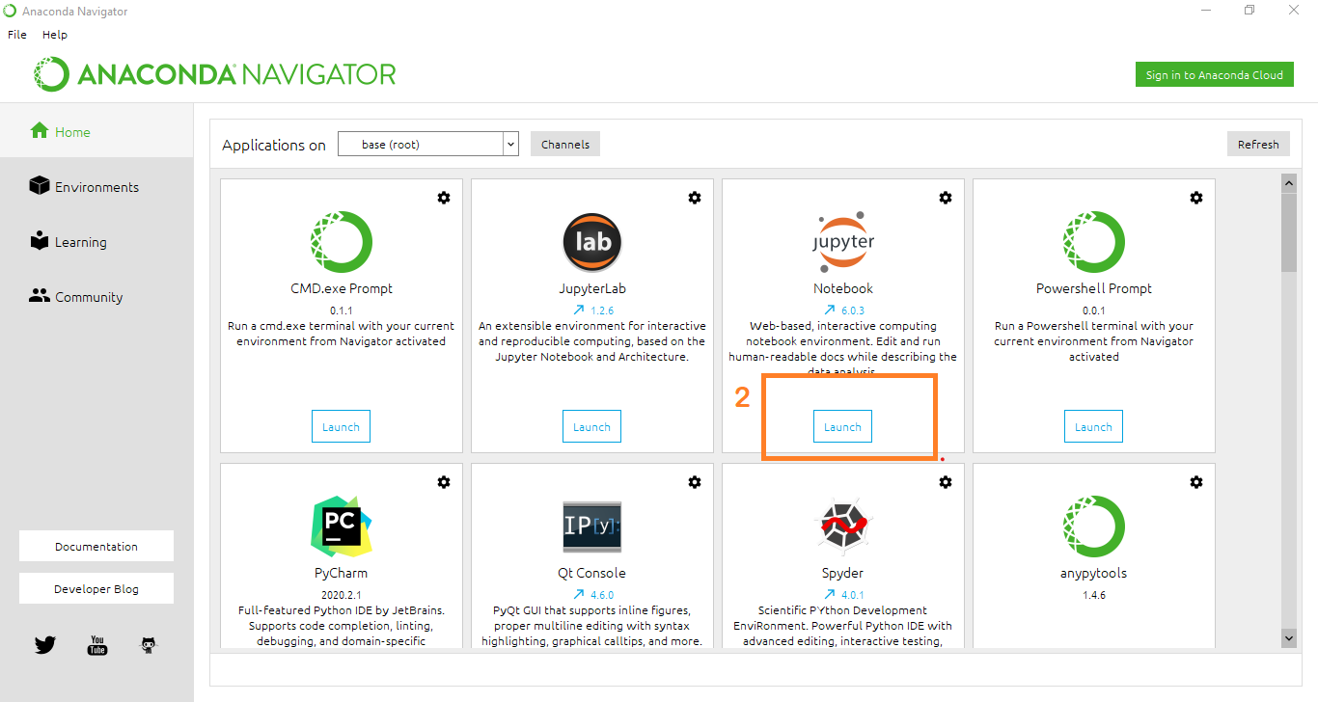

* Then you will be able to see that the jupyter notebook runs on local host:8888.
* To Create a new file Go to New 🡪Python3. The file in jupyter notebook is saved with .ipynb extension.

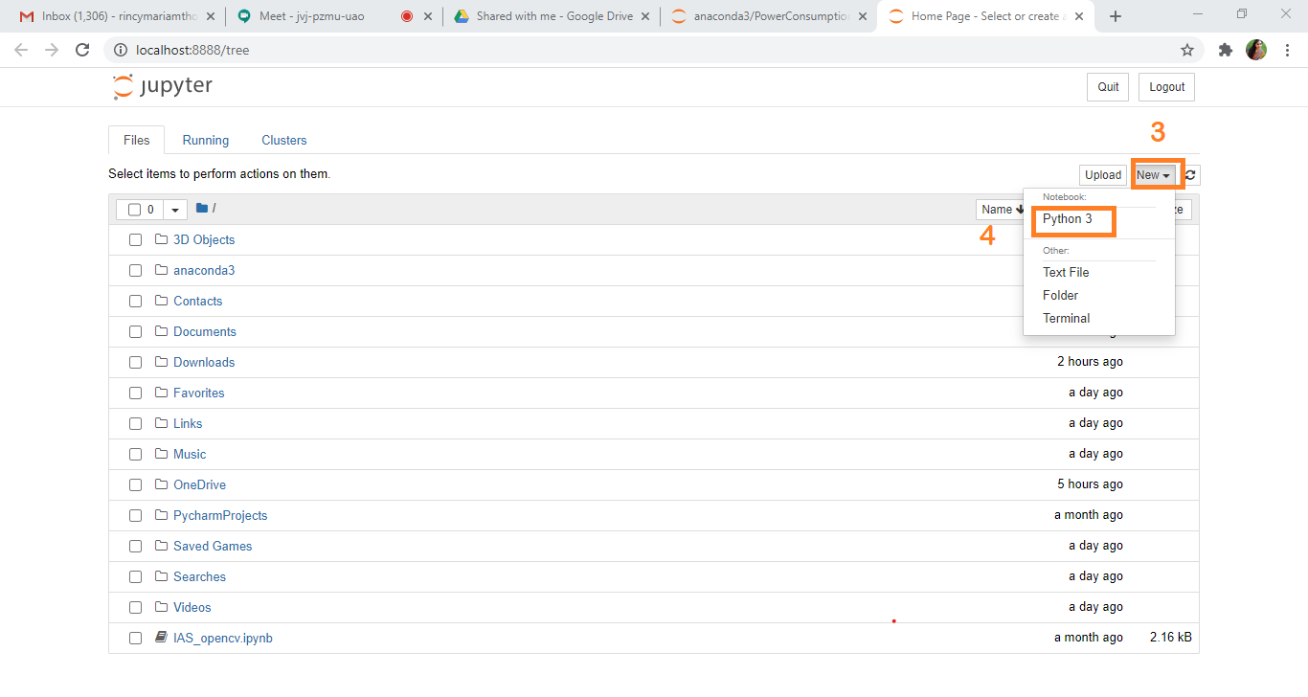

**Project Objectives:**

By the end of this project you will:

* Know fundamental concepts and techniques of time Machine learning algorithms.
* Know fundamental concepts of python
* Know how to install necessary packages and setting up the environment.
* Know how to build a web application using Flask framework.

**Project Flow:**

* User interacts with the UI (User Interface) to predict the values based on previous data
* The list of predicted output is showcased on the UI.
* Entered data is analyzed by the model which is integrated

To accomplish this, we have to complete all the activities and tasks listed below

* Data Collection.
  + Collect the dataset or Create the dataset
* Data Preprocessing.
  + Import the Libraries.
  + Importing the dataset.
  + Analyse the data
  + Taking care of Missing Data
  + Data Visualization
  + Splitting Data into Train and Test.
* Model Building
  + Import the model building Libraries
  + Initializing the model
  + Adding Machine Learning Model
  + Training the model
  + Model Evaluation
  + Save the Model
* Application Building
  + Create an HTML file
  + Build Python Code

**Project Structure:**

Create a Project folder which contains files as shown below

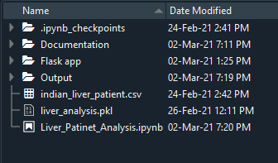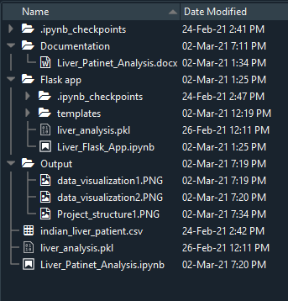

* We are building a Flask Application which needs HTML pages stored in the templates folder and a python script Liver_Flask_App.ipynb for serverside scripting
* Liver_Flask_App.ipynb - contains the actual python code that will import the app and start the development server.
* Liver_Patiner_Analysis.ipynb - This is where you define models for your application.
* Liver_analysis.pkl - This is our model weights file
* templates - This is where you store your html templates i.e. index.html, lweb.html

**Milestone 1: Data Collection**

ML depends heavily on data, without data, a machine can't learn. It is the most crucial aspect that makes algorithm training possible. In Machine Learning projects, we need a training data set. It is the actual data set used to train the model for performing various actions.

**Activity 1: Download dataset /create dataset**:

You can collect datasets from different open sources like kaggle.com, data.gov, UCI machine learning repository etc.

The dataset used for this project was obtained from Kaggle. Please refer to the link given below to download the data set and to know about the dataset

* + **Link**:<https://drive.google.com/file/d/1JgvhiD6kx_oRTYRZDlmkCcYXWxJMWf2Y/view?usp=sharing>
  + Liver Patient Analysis contains several columns.

**Milestone 2: Data Preprocessing**

Data Pre-processing includes the following main tasks

* + Import the Libraries.
  + Importing the dataset.
  + Analyse the data
  + Taking care of Missing Data
  + Data Visualization
  + Splitting Data into Train and Test.

**Activity 1: Import the Libraries**

The first step is usually importing the libraries that will be needed in the program.

The required libraries to be imported to Python script are:

**Numpy:** It is an open-source numerical Python library. It contains a multi-dimensional array and matrix data structures. It can be used to perform mathematical operations on arrays such as trigonometric, statistical, and algebraic routines.

**Pandas**: It is a fast, powerful, flexible and easy to use open source data analysis and manipulation tool, built on top of the Python programming language.

**Matplotlib**: Visualisation with python. It is a comprehensive library for creating static,animated, and interactive visualizations in Python.

**Seaborn:** Seaborn is a library for making statistical graphics in Python. Seaborn helps you explore and understand your data. Its plotting functions operate on dataframes and arrays containing whole datasets and internally perform the necessary semantic mapping and statistical aggregation to produce informative plots.

**Pickle:** The pickle module implements serialization protocol, which provides an ability to save and later load Python objects using special binary format**.**

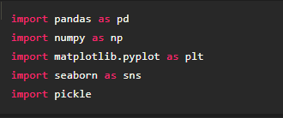

Note: It’s conventional to refer to alias. When you add the alias name at the end of your import statement, your Jupyter Notebook understands that from this point on every time you type alias name, you are actually referring to the particular library.

**Activity 2**: **Importing the dataset**

* You might have your data in .csv files, .excel files
* Let’s load the excel data file into pandas using the **read_excel() function.** We will need to locate the directory of the excel file at first (it’s more efficient to keep the dataset in the same directory as your program).



* If your dataset is in some other location, Then

Data=pd.read_excel(r”File_location”)

**Note:**r stands for "raw" and will cause backslashes in the string to be interpreted as actual backslashes rather than special characters.

* If the dataset in same directory of your program, you can directly read it, without giving raw as r.

**Activity 3** : **Analyse the data**

* head() method is used to return top n (5 by default) rows of a DataFrame or series.

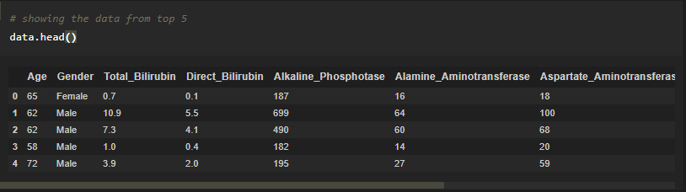

* tail() method is used to return bottom n (5 by default) rows of a DataFrame or series.

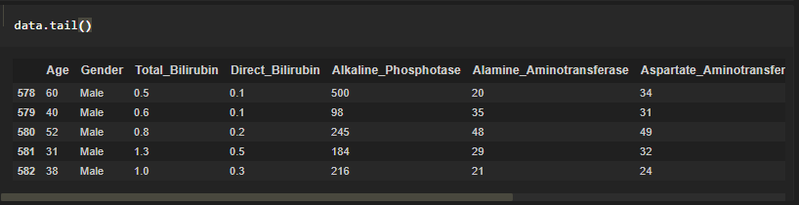

* describe() method computes a summary of statistics like count, mean, standard deviation, min, max, and quartile values.



The output is as shown below

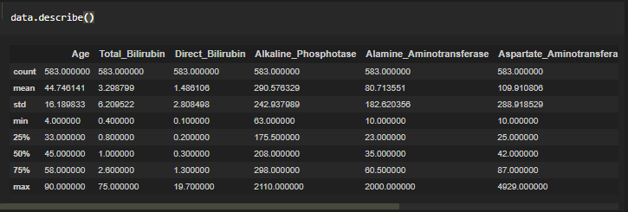

From the data we infer that there are 583 records

* info() gives information about the data

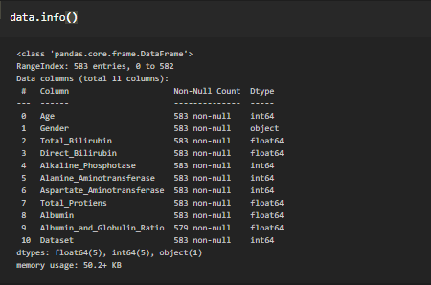

**Activity 4**: **Taking care of Missing Data**

1. After loading the dataset, it is important to check the complete information of such as null values in a column or a row

2.Check whether any null values are there or not. if it is present then the following can be done,

a.Imputing data using Imputation method in sklearn

b.Filling NaN values with mean, median, and mode using fillna() method.

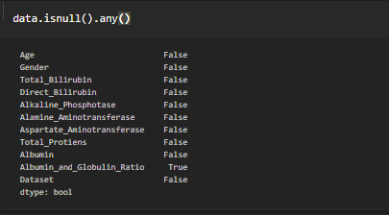

We can see that there are null values in the Albumin_and_Globulin_Ration Column.

Let us check how many numbers of null records present in the Closing Value column using sum() function.

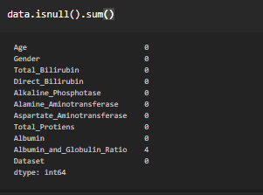

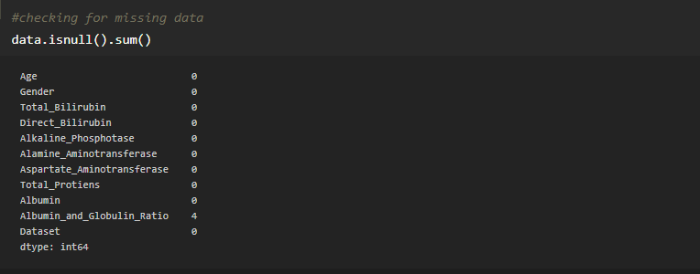

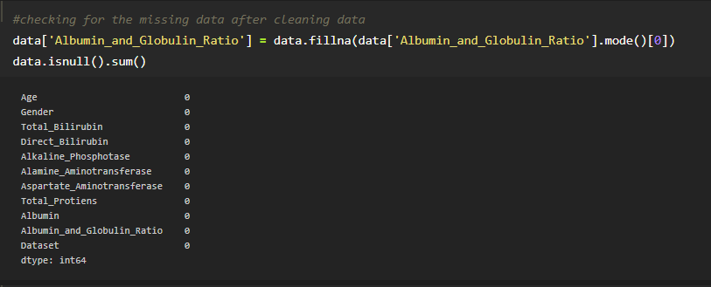

**Activity 5** : **Data Visualization**

**Link**: <https://towardsdatascience.com/data-visualization-for-machine-learning-and-data-science-a45178970be7>

* Data visualization is where a given data set is presented in a graphical format. It helps the detection of patterns, trends and correlations that might go undetected in text-based data.
* Understanding your data and the relationship present within it is just as important as any algorithm used to train your machine learning model. In fact, even the most sophisticated machine learning models will perform poorly on data that wasn’t visualized and understood properly.
* To visualize the dataset we need libraries called Matplotlib and Seaborn.
* The Matplotlib library is a Python 2D plotting library which allows you to generate plots, scatter plots, histograms, bar charts etc.

Let’s visualize our data using Matplotlib and searborn library.

Before diving into the code, let's look at some of the basic properties we will be using when plotting.

xlabel: Set the label for the x-axis.

ylabel: Set the label for the y-axis.

title: Set a title for the axes.

Legend: Place a legend on the axes.

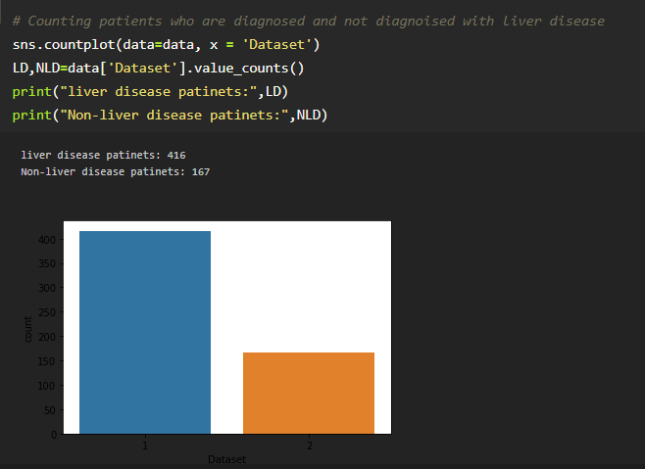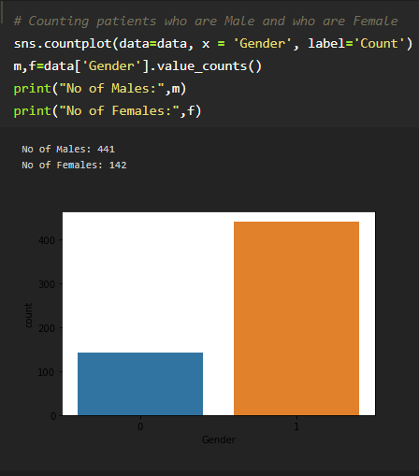

**Activity 6** : **Splitting Data into Train and Test**

* When you are working on a model and you want to train it, you have a dataset. But after training, we have to test the model on some test dataset. For this, you will a dataset which is different from the training set you used earlier. But it might not always be possible to have so much data during the development phase. In such cases, the solution is to split the dataset into two sets, one for training and the other for testing.
* 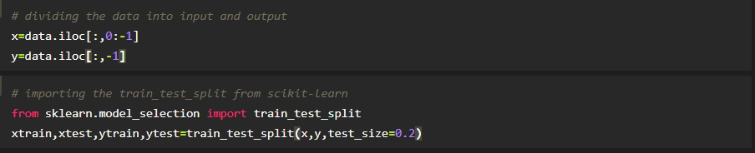
* **Scikit-learn:** Scikit-learn is probably the most useful library for machine learning in Python. The sklearn library contains a lot of efficient tools for machine learning and statistical modeling including classification, regression, clustering and dimensionality reduction. We can also called sklearn as short.
* **Sklearn.model_selection:** train_test_split is a function in Sklearn model selection for splitting data arrays into two subsets: for training data and for testing data. With this function, you don't need to divide the dataset manually. By default, Sklearn train_test_split will make random partitions for the two subsets.
* **Test_size():** This parameter decides the size of the data that has to be split as the test dataset. This is given as a fraction. For example, if you pass 0.5 as the value, the dataset will be split 50% as the test dataset. If you're specifying this parameter, you can ignore the next parameter.

The size of train and test data after splitting

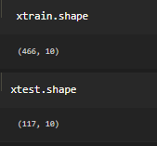

**Milestone 3: Model Building**

The model building process involves setting up ways of collecting data, understanding and paying attention to what is important in the data to answer the questions you are asking, finding a statistical, mathematical or a simulation model to gain understanding and make predictions.

Model Building Includes:

* + Import the model building Libraries
  + Initializing the model
  + Training the model
  + Model Evaluation
  + Save the Model

**Activity 1 : Importing the Model Building Libraries**

Importing the necessary libraries

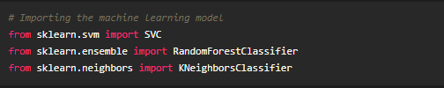

**Activity 2 : Initializing the model**

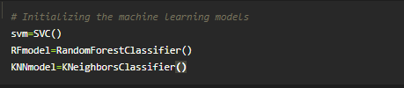

**Activity 6: Train and Testing the model**

In a dataset, a training set is implemented to build up a model, while a test (or validation) set is to validate the model built. Data points in the training set are excluded from the test (validation) set. The models generated are to predict the results unknown which is named as the test set.

Here we are used three different types machine learning models.

**Model 1: Support Vector Machine**

Support Vector Machine (SVM) is a supervised machine learning algorithm which can be used for both classification or regression challenges. However, it is mostly used in classification problems. Support Vectors are simply the co-ordinates of individual observation. The goal of a support vector machine is not only to draw hyperplanes and divide data points, but to draw the hyperplane the separates data points with the largest margin, or with the most space between the dividing line and any given data point

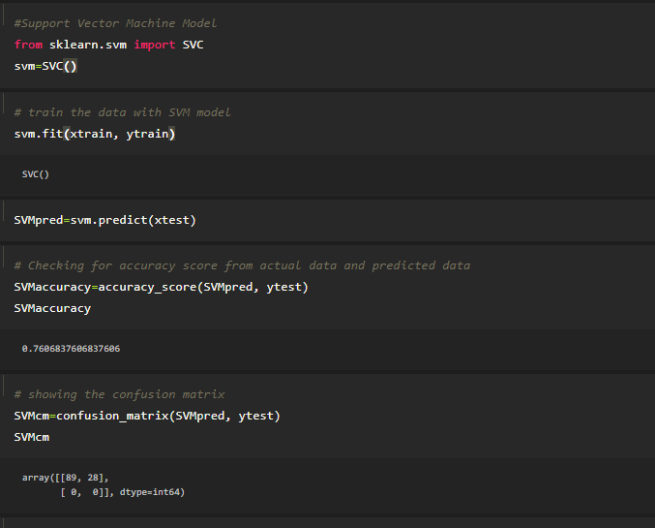

**svm.fit():** Model fitting is a measure of how well a machine learning model generalizes to similar data to that on which it was trained. A model that is well-fitted produces more accurate outcomes.

**svm.predict():** The predict() function accepts only a single argument which is usually the data to be tested. It returns the labels of the data passed as argument based upon the learned or trained data obtained from the model. Thus, the predict() function works on top of the trained model and makes use of the learned label to map and predict the labels for the data to be tested.

**Accuracy_score():** When taking scientific measurements, it is important to be both accurate and precise. Accuracy represents how close a measurement comes to its true value. This is important because bad equipment, poor data processing or human error can lead to inaccurate results that are not very close to the truth.

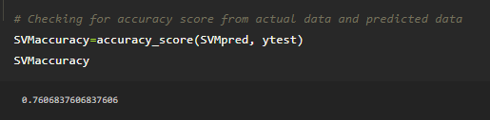

**Confusion_matrix():** A Confusion matrix is an N x N matrix used for evaluating the performance of a classification model, where N is the number of target classes. The matrix compares the actual target values with those predicted by the machine learning model. The rows represent the predicted values of the target variable.

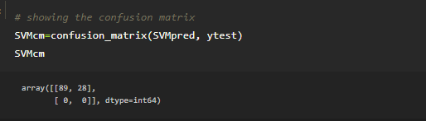

**Model 2: Random Forest Algorithm**

As the name suggests, "Random Forest is a classifier that contains a number of decision trees on various subsets of the given dataset and takes the average to improve the predictive accuracy of that dataset." Instead of relying on one decision tree, the random forest takes the prediction from each tree and based on the majority votes of predictions, and it predicts the final output.

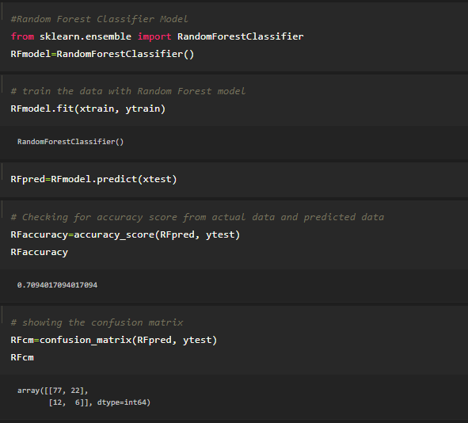

**RFmodel.fit():** Model fitting is a measure of how well a machine learning model generalizes to similar data to that on which it was trained. A model that is well-fitted produces more accurate outcomes.

**RFmodel.predict():** The predict() function **accepts only a single argument** which is usually the data to be tested. It returns the labels of the data passed as argument based upon the learned or trained data obtained from the model. Thus, the predict() function works on top of the trained model and makes use of the learned label to map and predict the labels for the data to be tested

**Accuracy_score():** When taking scientific measurements, it is important to be both accurate and precise. Accuracy represents how close a measurement comes to its true value. This is important because bad equipment, poor data processing or human error can lead to inaccurate results that are not very close to the truth

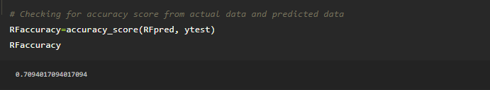

**Confusion_matrix():** A Confusion matrix is an N x N matrix used for evaluating the performance of a classification model, where N is the number of target classes. The matrix compares the actual target values with those predicted by the machine learning model. The rows represent the predicted values of the target variable.

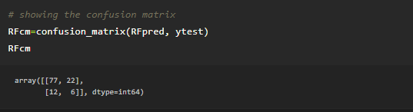

**Model3: K-Nearest Neighbors** **Algorithm**

K-Nearest Neighbour is one of the simplest Machine Learning algorithms based on Supervised Learning technique. K-NN algorithm assumes the similarity between the new case/data and available cases and put the new case into the category that is most similar to the available categories.

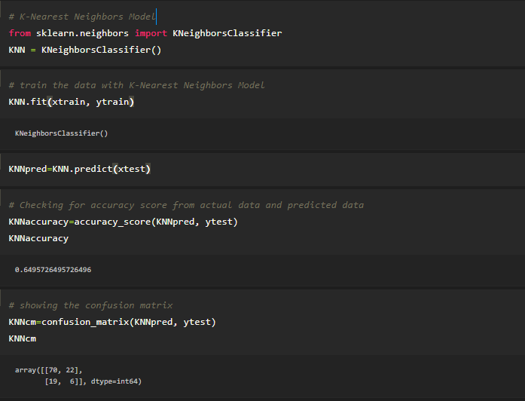

**KNN.predict():** The predict() function accepts only a single argument which is usually the data to be tested. It returns the labels of the data passed as argument based upon the learned or trained data obtained from the model. Thus, the predict() function works on top of the trained model and makes use of the learned label to map and predict the labels for the data to be tested

**Accuracy_score():** When taking scientific measurements, it is important to be both accurate and precise. Accuracy represents how close a measurement comes to its true value. This is important because bad equipment, poor data processing or human error can lead to inaccurate results that are not very close to the truth

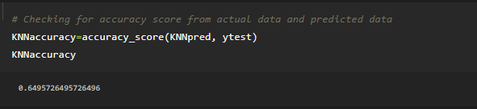

**Confusion_matrix():** A Confusion matrix is an N x N matrix used for evaluating the performance of a classification model, where N is the number of target classes. The matrix compares the actual target values with those predicted by the machine learning model. The rows represent the predicted values of the target variable.

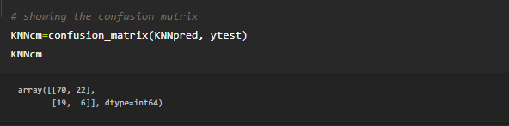

**Activity 7**: **Model Evaluation**

Finally, we need to check to see how well our model is performing on the test data.

**Classification Evaluation Metrics:**

### Classification Accuacy:

Classification Accuracy is what we usually mean, when we use the term accuracy. It is the ratio of number of correct predictions to the total number of input samples.

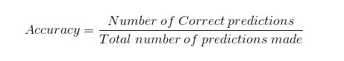

### Confusion Matrix:

Confusion Matrix as the name suggests gives us a matrix as output and describes the complete performance of the model.

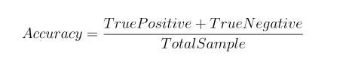

**Activity 8: Save the Model**

The model is saved with .pkl extension as follows

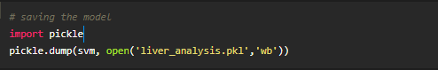

**Milestone 4: Application Building**

* + **Link**: <https://thesmartbridge.com/documents/spsaimldocs/FlaskML.pdf>

**Activity 1 : Create an HTML File**

* We use HTML to create the front end part of the web page.
* Here, we created 4 html pages- index.html, home.html, chance.html, nochance.html.
* Home page displays the introduction of project
* index.html accepts the values from the input and displays the prediction.
* For more information regarding HTML refer the link below.
  + **Link:** [**https://www.w3schools.com/bootstrap/bootstrap_forms_inputs.asp**](https://www.w3schools.com/bootstrap/bootstrap_forms_inputs.asp)
  + **Link:**<https://www.w3schools.com/css/>

**Activity 2 : Build python code**

* Let us build flask file ‘Liver_Flask_App.ipynb’ which is a web framework written in python for server-side scripting. Let’s see step by step procedure for building the backend application.
* App starts running when “__name__” constructor is called in main.
* render_template is used to return html file.
* “GET” method is used to take input from the user.
* “POST” method is used to display the output to the user.
* Importing Libraries

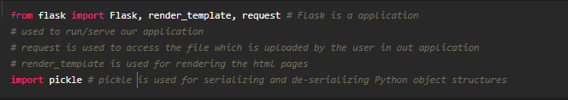

* + Routing to the html Page

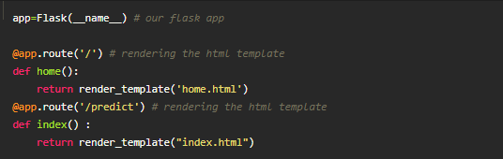

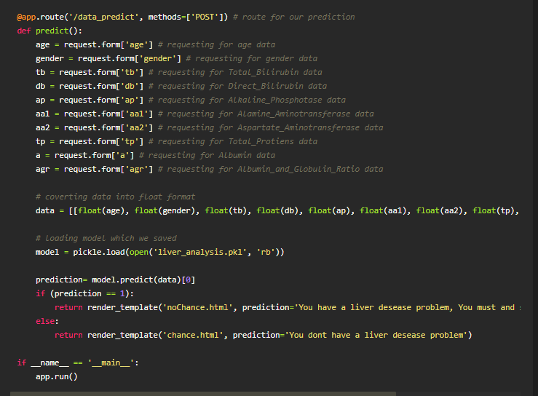

**Activity 3: Run The app in local browser**

* + Open jupyter notebook from the start menu
  + Navigate to the folder where your python script is.
  + Now press Ctrl+Enter
  + Navigate to the localhost where you can view your web page

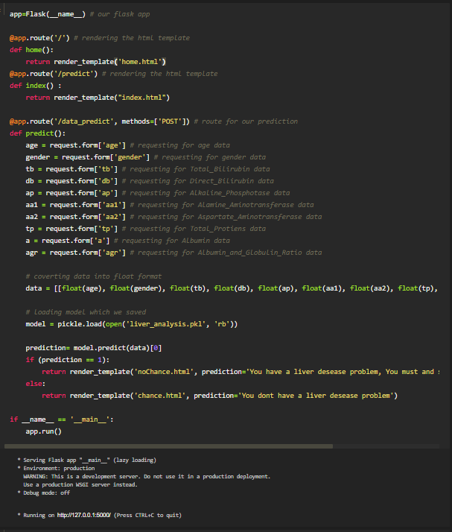

**Activity 4: Showcasing prediction on UI**

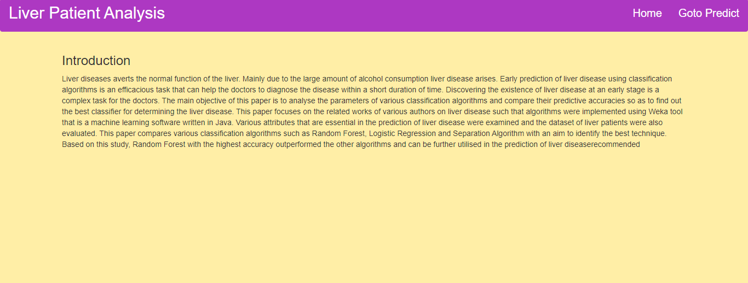

This is our home page where we get to know the summary of the project.

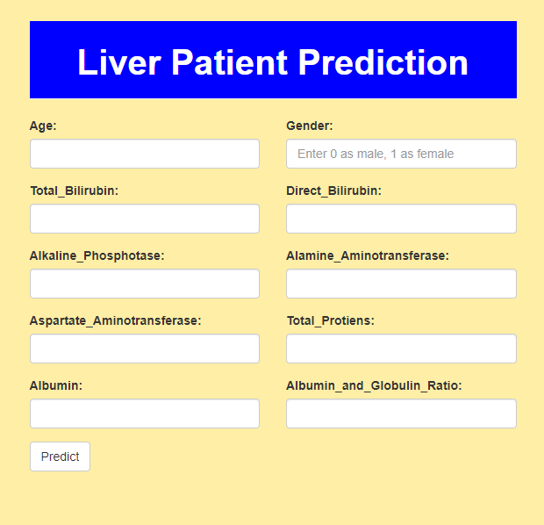

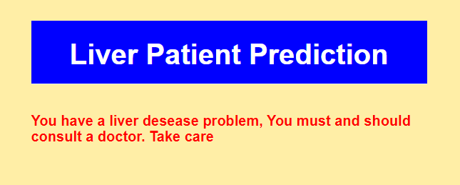

As we see the predicted output is displayed on the User Interface